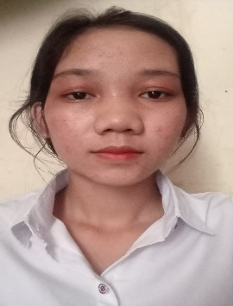Kingdom of Cambodia National Religion King

………….

**CURRICULUMVIAE**

Name: SRIV NARY

Address: choum chav, khan pur sean chaiv, Phnom Penh Cambodia

# Tel: 0966496332

# PERSONAL INFORMATION

Date of birth : 05 Jun 2002

Sex : Female

Nationality : Khmer

Place of birth : Takeo Province Praikabas District Angkanh Commune

Material status : Single

Health : Good

# EDUCATION BACK GROUND

2013-2016 : Finish Grade 9 at Banoy Secondary school

2016-2020 ; Finish Grande 12 at Banoy high school

2021-Present : Studying at National University of Management (NUM)

WORK EXPERIENCE

* Customer Service

# LANGUGE

Khmer : Mother Tongue

English : Speaking writing Listening is a little

# STATUS OF PERSONALYTY

* Willing to learn new skills
* Have responsibility and confidence
* Can face and resolve with the incoming problem
* Have good relations with the Workgroup

COMPUTER SKILLS

Word, Excel, PowerPoint a little

# INTERESTING

* Reading and search on internet
* Find out what’s new on internet
* Listening music (Khmer and English song)
* Preferring to share ideas in order to promote understandable and practical skills

# REFERNCES

Name : NHEAV SREUON (Father)

Telephone : 081577297

WORK EXPERRIENCE

* Reply chat customer